FEEDBACK WORK AND BACKEND ALSO SOUCRCE CODE OF BUTTON

**SOURCE CODE OF BUTTON**

**DELETE BUTTON**

GO_BLOCK('CREW');

DELETE_RECORD;

**ADD BUTTON**

GO_BLOCK('CREW');

CREATE_RECORD;

COMMIT;

**NEXT** **BUTTON**

GO_BLOCK('CREW');

NEXT_RECORD;

**PREVIOUS** **BUTTON**

GO_BLOCK('CREW');

PREVIOUS_RECORD;

**OPEN BUTTON**

GO_BLOCK('HOME');

SHOW_VIEW('HOME');

HIDE_VIEW('CREW');

**UPDATE** **BUTTON**

go_block('STAFF');

commit;

**SEARCH BUTTON**

IF :PTS=1 then

GO_block ('STAFF_SEARCH');

set_block_property('staff_SEARCH',onetime_where,'STAFF_ID=:CTRL.PTSIN');

EXECUTE_QUERY;

END IF;

**FEEDBACK**

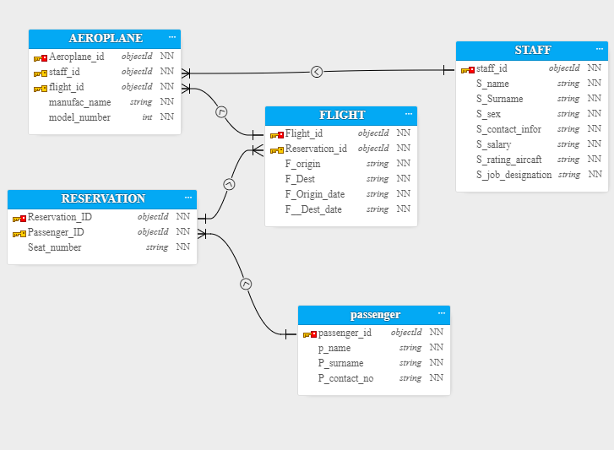

DATA DEFINITION LANGUAGE

We performed DDL

PASSENGER TABLE

create table passenger(passenger_id int , p_name varchar2(50),p_surname varchar2(50) ,p_contact_no int, constraint passenger_id_pk primary key(passenger_id));

RESERVATTION TABLE

create table reservation(reservation_id int , passenger_id int , seat_no int,

constraint reservation_id_pk primary key(reservation_id) ,

Constraint resvervation_passenger_fk foreign key(passenger_id)

references passenger(passenger_id));

FLIGHT TABLE

create table Flight(Flight_id int ,reservation_id int , F_origin varchar2(40) ,F_dest varchar2(40) ,f_origin_Date date ,f_dest_date date,

constraint Flight_id_pk primary key(Flight_id) ,

Constraint Flight_reservation_fk foreign key(reservation_id)

references reservation(reservation_id));

AEROPLANE TABLE

create table aeroplane(Aeroplane_id int ,staff_id int , Flight_id int , manufac_name varchar2(50),model_number int,

constraint aeroplane_id_pk primary key(aeroplane_id) ,

Constraint aeroplane_flight_fk foreign key(flight_id)

references flight(flight_id),

Constraint aeroplane_Staff_fk foreign key(staff_id)

references staff1(staff_id));

create table Staff1(Staff_id int ,S_name varchar2(50),S_surname varchar2(50),S_Sex varchar2(50),S_contact_infor int ,S_salary int , S_rating_aircraft varchar2(50) ,S_job_designation varchar2(50) ,

Constraint Staff_id_pk primary key(Staff_id));

DATA MANILPUTE LANGUAGE

insert into passenger

values(11251,'Safder','Lashari',9223131241);

values(11252,'Ali shah','Baloch',9223122321);

values(11253,'Raj Veer','Rajpoot',922231411);

values(11254,'Ahmed','laghri',9221231221);

values(11255,'Khan Muhammed','Sammo',9223233221);

insert into reservation

values(98811,11251,98);

values(98812,11252,34);

values(98813,11253,64);

values(97911,11254,36);

values(97912,11255,15);

insert into flight

values(99921,98811,'Hyderabad','Dubai',to_date('13/11/2019','dd/mm/yyyy'),to_date('13/11/2021','dd/mm/yyyy'));

values(99922,98812,'Hyderabad','Dubai',to_date('13/11/2019','dd/mm/yyyy'),to_date('13/11/2021','dd/mm/yyyy'));

values(99943,98813,'Gujarat ','Mumbai',to_date('11/11/2019','dd/mm/yyyy'),to_date('12/11/2021','dd/mm/yyyy'));

values(99994,97911,'Mumbai','Delhi',to_date('14/11/2019','dd/mm/yyyy'),to_date('14/11/2021','dd/mm/yyyy'));

values(99995,97912,'Mumbai','Delhi',to_date('14/11/2019','dd/mm/yyyy'),to_date('14/11/2021','dd/mm/yyyy'));

values(99126,97911,'Delhi','Mumbai',to_date('21/11/2019','dd/mm/yyyy'),to_date('21/11/2021','dd/mm/yyyy'));

insert into Staff1

values(190001,'Abha','Singh','Male',9120211111,200000,'Air India ,Air Indian Express,Akasa Air','Pilot');

values(190002,'Aarav','Gupta','Female',915333332,120000,'Air India','Air host');

values(190003,'Aditi','Agrawal','Female',9153322333,210000,'Air India ,AirAsia India,Akasa Air','Pilot');

values(190004,'Adarsh','Doshi','male',9143332322,250000,'Airline ,Air Indian Express,Akasa Air','Pilot');

values(190005,'Alka','Bansal','Female',9124323422,119000,'Akasa Air','Air host');

insert into aeroplane

values(111212,190001,99921,'India',1003212);

values(111213,190004,99995,'India',1003212);

values(111214,190003,99922,'India',1003212);

values(111211,190003,99921,'India',1003212);

values(111215,190004,99126,'India',1003212);